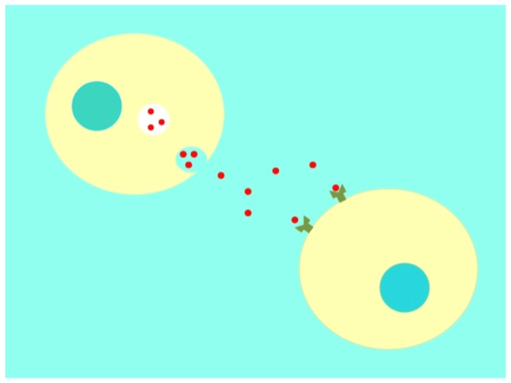

I Symposium on Cell communication in cancer &

Science Xpression Worshop

**June 15-23, 2015**

***APPLICATION FORM***

**1. Full name**

**2. Institutional affiliation (School, University, Graduate Program, City)**

**3. Professional Status**

High school ( )/ Graduation year:________

Undergraduate ( ) / Course: ______________ / Graduation year: ________

Graduate: Master ( ) Doctoral ( )

Postdoctoral ( ) / Year of doctoral degree: ________

Other ( ) / Specify: _________

**4. Contact**

E-mail:

Contact Telephone:

**5. CV Lattes link (copy it here)**

**6. Your ability to understand and speak in English is:**

( ) Low ( ) Intermediate ( ) Advanced

**7. Why take the course? Provide a statement of your reasons for wanting to take this course. Why do you think you should be chosen to participate of the Science Xpression Workshop? (max. 200 words).**